**Financial Accounting**

*After studying this chapter, you should understand the purpose of the three most important items in the annual report:*

* *the balance sheet;*
* *the profit and loss account; and*
* *the cash flow statement.*

*These are known as the financial statements and together they provide a picture of the overall financial health of the business. You should be able to interpret them in simple cases.*

* In Pakistan the companies submit these reports to the license providing authority namely **SECP**; Securities and Exchange Commission of Pakistan .

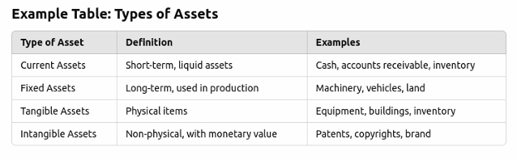

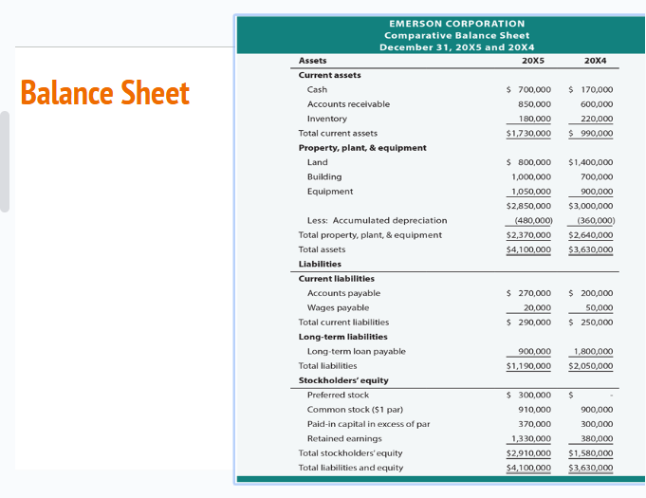

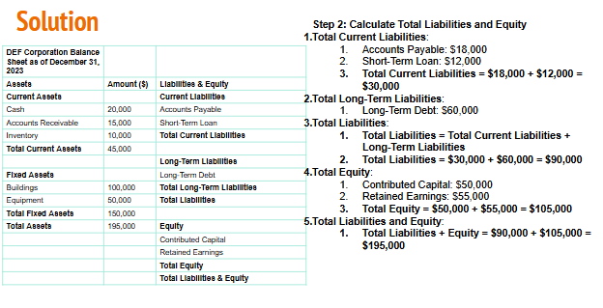

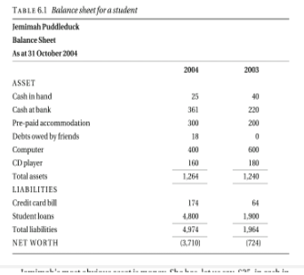

**THE PROFIT AND LOSS ACCOUNT**

The *profit and loss account* shows how much money has been received and how much has been spent in a given period – usually the organization’s financial year.

In the case of non-profit-making organizations it is usually called an *income and expenditure* account.

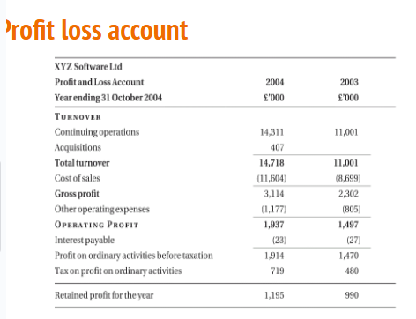

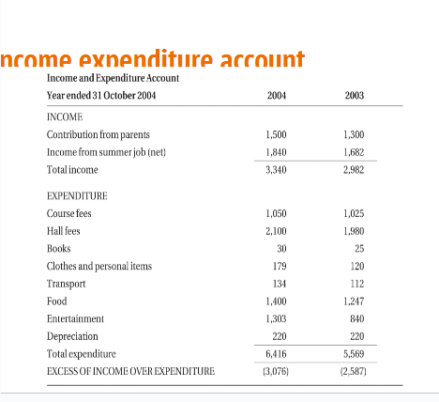

**THE CASH FLOW STATEMENT**

Parents usually investigate about the expenses of their kids. Often during childhood we were asked for where we spent our money. If we bought any thing we were asked from where did the money come.

Thus creating a flow “from where to where” these accounts show cash flow.

The link that ties the balance sheet and the profit and loss account to the capital expenditure is the cash flow statement.

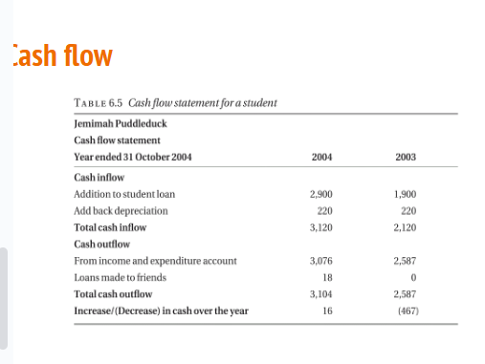

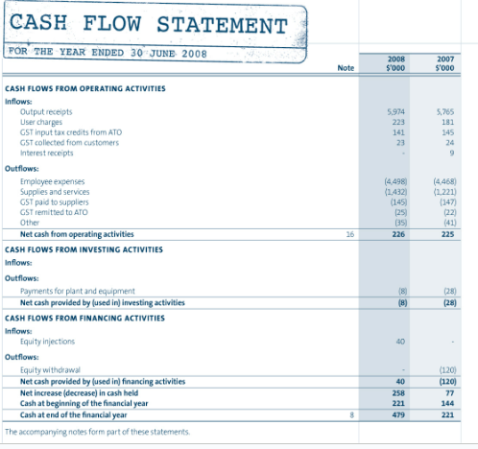

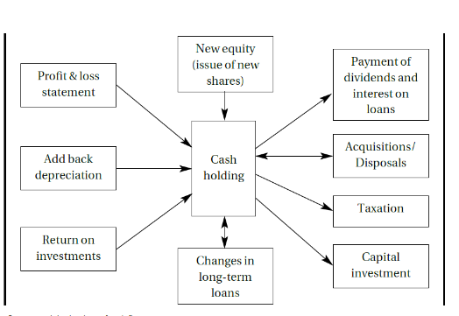

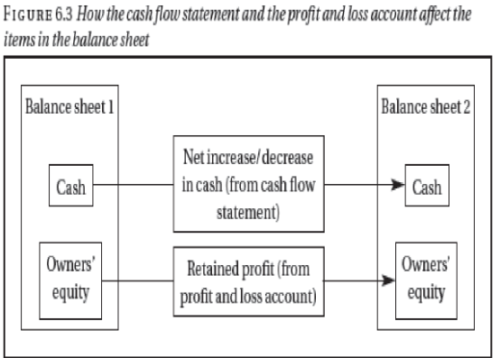

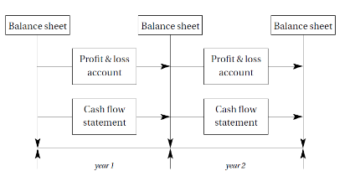

**Management accounting**

Management accounting is the process of preparing and analyzing financial information to help managers make informed business decisions.

**Difference Between Financial and Management Accounting**

**Management Accounting  Financial Accounting**

* Reports used internally  Reports used externally
* Will report on specific interest areas  Will report on business-wide performance
* Focused on future performance  Looks at historic performance
* Will use estimations  Is required to use accurate numbers
* Customizable and flexible based on Must produce information in accordance with managerial needs  accounting standards

**Payroll & cost of Labor**

* **What it is**: Payroll is **the amount of money** a company pays to its employees for their work.
* **What's included**:
  + **Wages or salaries** (what the employee earns).
  + **Bonuses**, if given.
  + **Deductions** like taxes, health insurance, and retirement contributions.
* **Purpose**: It's simply the process of paying employees and keeping track of their payments.
* **Example of Payroll:**
* You have an employee named Ali who earns $1,000 per month.
* Ali has 100 deducted for taxes and $50 for health insurance.
* So, Ali takes home **850** (after deductions).
* In this case, your payroll system tracks:
  + **Gross Pay** (before deductions): 1,000.
  + **Deductions**: 150.
  + **Net Pay** (after deductions): 850.

**Cost of Labor**

* **What it is**: The **total expense** a company incurs to employ workers. This includes payroll **plus other costs** related to having employees.
* **What's included**:
  + The **employee's pay** (which is part of payroll).
  + **Benefits** the company provides (health insurance, retirement contributions).
  + **Employer taxes** (what the company has to pay to the government for hiring employees).
  + **Other costs**: Like training, equipment, or uniforms for employees.
* **Purpose**: It shows how much it actually costs the company to have employees (not just their pay).
* **Example of Cost of Labor:**
* Using Ali again:
  + Ali's salary: **$1,000** (this is part of payroll).
  + The company also pays:
    - **$100** for Ali's health insurance.
    - **$80** for employer taxes (what the company pays to the government).
* So, the total **cost of labor** for Ali is:
  + Salary ($1,000) + Health Insurance ($100) + Employer Taxes ($80) = **$1,180**.
* This is **more than just payroll** because it includes other expenses the company pays for Ali.

**Cost of labor**

**Indirect Labor Costs**:

* These are wages paid to employees who do not directly contribute to the production of goods but provide support services. Indirect labor cannot be traced to a specific product.

**Example**:

* In the same car manufacturing company, the security personnel or maintenance staff do not directly work on the production line, but their wages still need to be paid. If a maintenance worker is paid $3,000 per month,

this is an **indirect labor cost**. Since their services affect the entire factory, the cost is spread across all products.

* **Direct Labor Costs**:

These are wages paid to employees who are directly involved in producing goods or delivering services. These costs can be traced back to specific products.

* **Example**:

In a car manufacturing company, the workers assembling the car on the production line are considered direct labor. If these workers are paid $20 per hour and they spend 100 hours assembling one car, the direct labor cost for producing that car would be:

* **Direct Labor Cost** = $20/hour × 100 hours = **$2,000** per car.

**Example**

* Example for a Full Company Setup:

1. **Direct Labor**:
   1. In a bakery, the bakers making bread are direct labor.
   2. If each baker earns $15 per hour and works 160 hours a month, their total direct labor cost is:
      1. **Direct Labor Cost** = $15/hour × 160 hours = **$2,400** per baker.
2. **Indirect Labor**:
   1. The bakery's cashier or supervisor who oversees operations is indirect labor.
   2. If a cashier earns $1,800 per month, this is an indirect labor cost.
3. **Other Costs**:
   1. The bakery also pays $200 per employee for health insurance and $100 for employer taxes.
4. **Total Cost of Labor for One Baker**:
   1. **Salary**: $2,400.
   2. **Employer Costs**: $200 (health insurance) + $100 (taxes).
   3. **Total Cost of Labor** = $2,400 + $200 + $100 = **$2,700** per baker.

**Overhead**

* **Overhead** refers to the indirect costs incurred by a business that are necessary for running operations but are not directly tied to producing goods or services.
  + These costs are essential for keeping the business functioning but don’t directly generate revenue.
* **Why Overhead Matters:**
* **Cost Control**: Managing overhead is key to maintaining profitability. If overhead expenses grow too large, they can eat into profits.
* **Pricing**: Understanding overhead helps businesses set prices that cover not just the cost of production but also the cost of running the business.
* **Budgeting**: Effective management of overhead helps in financial planning and controlling unnecessary expenses.
* **Profitability**: Overhead affects a company’s **break-even point**, which is the level of sales needed to cover all expenses. A high overhead means a company must sell more to break even.

**Overhead- Types of Overhead Costs**

* Fixed Overhead Costs
  + Rent, salaries, insurance, Depreciation
* Variable Overhead Costs
  + Utilities, supplies, packaging cost
* Semi-Variable (Mixed) Overhead Costs
  + Maintenance:
  + Telephone and Internet Bills

**Allocating Overhead to Products and Services**

* Since overhead costs are indirect, they cannot be traced to a specific product or service. Therefore, companies use various methods to allocate overhead across products or services. Two common methods include:
* **Absorption Costing:**
  + All overhead costs are assigned to products based on a specific allocation base, such as labor hours or machine hours.
  + **Example**:
* A company with $50,000 in overhead costs produces 10,000 units. Using absorption costing, each unit is allocated:
  + **Overhead per unit** = $50,000 ÷ 10,000 = **$5 per unit**.
* **Activity-Based Costing (ABC):**
* This method assigns overhead costs based on the actual activities that generate those costs. It's more precise because it identifies specific activities responsible for overhead.
* If a company spends $10,000 on electricity, and 60% of that electricity is used in production, then $6,000 is assigned to products, while the remaining $4,000 might be allocated to overhead categories like lighting and office equipment.

**Overhead and Profitability**

Overhead has a significant impact on a company’s **profit margins** and **break-even point**. If overhead is too high relative to sales, it can:

* **Reduce the company’s profitability.**
* **Increase the price of products to cover the overhead.**
* **Force the company to sell more just to break even.**

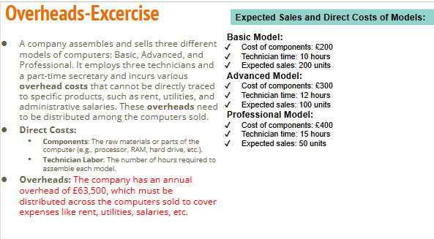

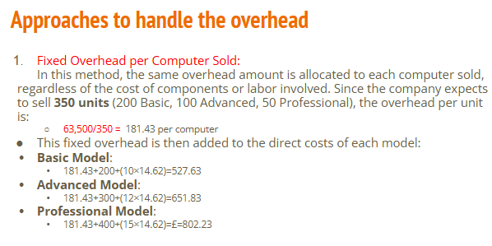

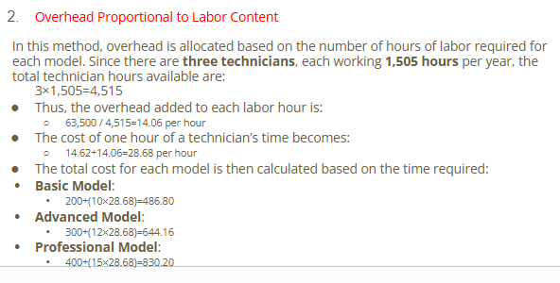 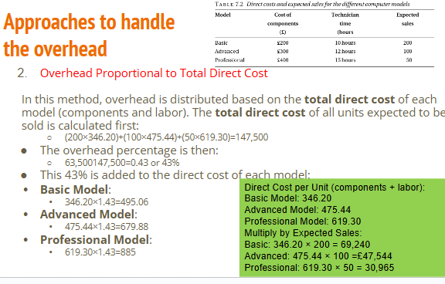

**BUDGETING:** A budget is a financial plan showing the expected income and expenditure for an organization over a specific period, typically one year.

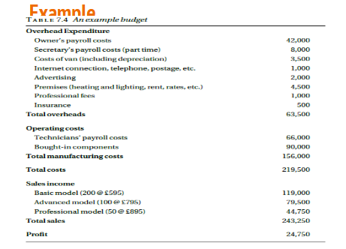

**CASH FLOW FORECAST**

A company may be very profitable but unable to pay its bills. For that reason, it may be forced into receivership. This apparent paradox typically arises because bills have to be met, in particular staff have to be paid, before the income they generate is received. In order to avoid this difficulty businesses need to prepare cash flow forecasts, that is, estimates of the amount of money that will flow into and out of the company each month.

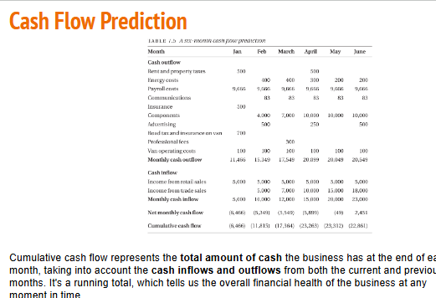

**Investment Appraisal**

Less resources and more number of proposals lead company owners and investors to decide which proposal to drop which to pick.

**Time Value of Money**

**The Car Purchase Scenario**

Imagine you want to buy a car. You have two options:

1. **Pay £8,995 upfront in cash.**
2. **Choose a payment plan**: Pay £500 now and then £400 per month for the next 24 months (2 years).

To figure out which option is better, you need to think about the **Time Value of Money** (TVM). TVM means that **money today is worth more than the same amount of money in the future**

**THE TIME VALUE OF MONEY**

Money available at present time is worth more than the same amount in the future due to its potential earning capacity.

**Purchasing vs leasing**

Suppose you want to get a car worth Rs.10,00,000/- and you have that amount.

The car finance department offers you to lease the car providing you pay a down payment of 20% that is Rs.2,00,000/- and a monthly payment of Rs.20,000 for 5 years(60 months).

Thus,

(20,000 * 60) + 2,00,000 = 14,00,000

While if you purchase it you have to pay Rs. 10,00,000/-

Would you purchase the car or lease it on these terms?

**Interest rate**

Suppose you put your Rs.10,00,000/- in the bank provided the bank gives you an interest of 10% per annum

Thus (10/100) * 10,00,000 = 100,000 per annum

**Discount factor**

In general, if the interest rate is r (expressed as a fraction such as 0.08, not a percentage), then the present value of a sum of money X due in t years time is:

X ÷(1 + *r*)*t*

**QUESTION:**

A new van will cost £10,000. There will be annual costs of £500 for insurance and £150 for road tax. The cost of maintenance is estimated to be £200 in each of the first two years, £300 in year 3, £400 in year 4 and £500 in year 5.

At the end of the fifth year, it is expected that the van will be sold for around £2,000. The interest rate that the company pays on its borrowings is 10 percent.

**If the van is hired(rented)**

 Van hire costs £35 per day and it hires a van for about 100 days a year. All the costs are subject to inflation, which is judged to be around 5 per cent over the period, but the resale value of the van is the cash figure expected at the

time.

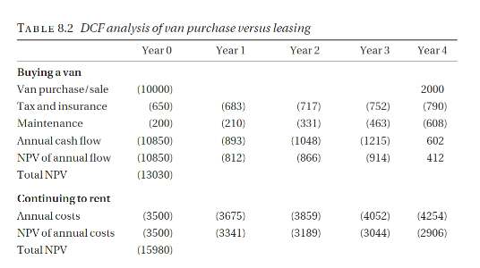

**Cost of capital**: Even if the company has the cash available to buy the van outright, there is still a cost because the company will lose the income it could have received by investing the money somewhere else, in a suitable interest bearing account for example. Such a cost is known as an *opportunity cost. If the company* is able to pay cash for the van, this is the interest rate it would be appropriate to use in the DCF analysis.

**Handling inflation**: Inflation in a financial context means the fall in the value of money over time

**Software company example**

* We consider a company that is assessing a proposal for the development of a software product. It is estimated that three people will be required for development in the first year and a further person and a half in the second year; suitable staff cost £35,000 per year, including the employer’s pension and national insurance costs. The product will be released in the second year. After the second year, maintenance is expected to require one person, full-time. Sales and marketing costs are estimated to be £10,000 in the first year, rising to £20,000 for each of the next four years.
* The product itself is a fairly high-value but specialized product. It is expected that about 100 copies will be sold over this period, at around £5,000 a copy.

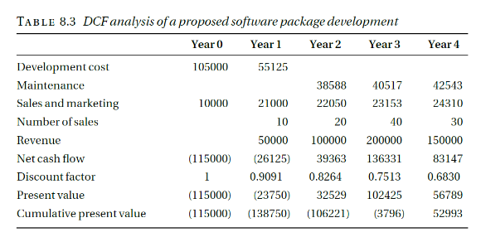

**PITFALLS OF DCF**

we must take into account that:

* most software projects take more effort than expected;
* most software doesn’t work very well when it’s first released;
* we may not manage to sell as many copies as we expected;
* there is a considerable risk that a competitor will launch a similar product before ours is ready.

**Structure and Management of  
Organizations**

* *How Organizations are structured?*
* *How can you suggest alternative possible structures and identify their advantages and disadvantages.*

**Introduction**

**Definition:**  An organization is a group of people working together in a formal way.

**Explanation:** The work that has to be done is shared between these people and there are rules about who does what.

* How the work is shared and how tasks and people are grouped together – the structure of the organization – will vary very much from organization to organization. It is surprising, however, that organizational structures have much more in common than might be expected.

***ORGANIZATIONAL MODELS***

* ***The bureaucratic model***
* ***The organic model***
* ***Matrix management***

***The bureaucratic model****: Organizational theory is the study of how organizations are structured and how they work.(19th century)*

*The founders of the theory were sociologists like Max Weber and Mary Parker Follett, and practical business people like Henri Fayol and Lyndall Urwick.*

*In a modified form, this model still describes the organizational structures to be found in most large, and many smaller, organizations. This is not realistic in the context of project-based, high-technology companies.*

***1)The bureaucratic model characteristics***

*The ideal bureaucratic organization was thought to have the following characteristics:*

1. *All tasks are split up into specialized jobs, in which jobholders become expert; management can thereby hold the jobholders responsible for the effective performance of their duties.*
2. *The performance of each task is governed by precise rules. This means that there should be no variation in the way tasks are carried out and therefore no problems with the co-ordination of different tasks.*
3. *Each individual (and hence each unit) in the organization is accountable to one and only one manager.*
4. In order to ensure that personalities and personal relationships do not interfere with the organization’s performance, employees are required to relate both to other employees and to clients in an impersonal and formal manner.
5. Recruitment is based on qualifications and employees are protected against arbitrary dismissal. Promotion is based on seniority and achievement. Life-time employment is envisaged.

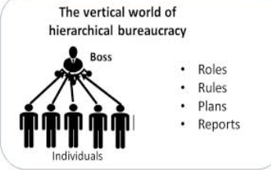

**2) The organic model**

The best known alternative model is the *organic* model

Rensis Lickert expresses the basic assumption of the model in the following (rather verbose) terms:

**“An organization will be effective to the extent that its structure is such as to ensure a maximum probability that in all interactions and in relationships within the organization, each member, in the light of his background, values, desires, and expectations, will view the experience as supportive and one which builds a sense of personal worth and importance.”**

**Key features of organic model**

* This view underlies the organizational structure of most small professional companies – software houses, advertising agencies, even solicitors’ and GPs’ practices
* it is also common in academic institutions, both schools and universities. The view is not necessarily consciously articulated – nor is this view and the adoption of the structures it suggests sufficient to achieve effectiveness!
* Proponents of the bureaucratic model claim that it is universally applicable.
* Proponents of the organic model make similar claims.
* It says little for common sense that those who hold the obvious view that each has its appropriate place should be christened adherents of the contingency school of organizational design.

**3) Matrix management**

* It is an essential feature of the bureaucratic model that every individual and every unit in the organization is responsible to only one manager.
* This is not realistic in the context of project-based, high-technology companies.
* It accepts that individuals may be responsible to more than one manager and requires rules that will enable possible conflicts to be resolved.
* Some organizations and some management consultants have tried to formulate the matrix management model much more formally. The results are not encouraging.

A specialist in high-speed communications working for a systems integrator may well find themselves working on two or three projects simultaneously, as well as having a more general responsibility for maintaining the company’s expertise in the area.

In the past 30 years or so the idea of matrix management has become fashionable as a way of addressing such situations.

**STRUCTURING PRINCIPLES**

* Structure by function
* Structure by geography
* Product line structure
* Structure by market sector
* Structure by technology
* Operational structure

**1)Structure by function**

There are the activities that are the primary purpose of the organization. These activities are known as *operations*.

All organizations have to pay their bills and pay their employees. They need to ensure that the buildings they use are cleaned regularly. If they charge for their services, they may need to send out bills and ensure that these are paid. They will probably need to hire new employees from time to time. These activities are generally known as *administration*.

Many organizations will need to publicize their services or their products and try to persuade people to use them or buy them. In the business world these activities are usually known as *sales and marketing*.

Finally, many organizations need to be continually developing new products or services, or developing new ways to deliver them. These activities are known as research and development.

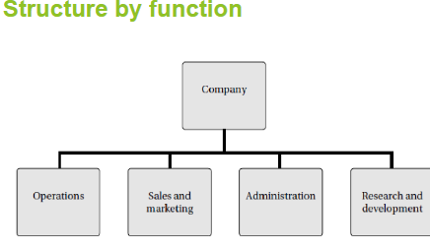

**Strategic Advantages/Disadvantages**

*Strategic Advantages*

* Permits centralized control of strategic results
* Promotes in-depth functional expertise
* Enhances operating efficiency where tasks are routine and repetitive

*Strategic Disadvantages*

* Poses problems of functional coordination
* Can lead to inter functional rivalry, conflict, and empire-building
* May promote overspecialization/ narrow viewpoints

**2) Structure by geography**

* In many cases it makes sense to group activities together on a geographical basis. Multinational companies, that is, companies that operate in a number of different countries, are usually forced to have some geographical elements in their structure.
* The subsidiaries are subject to the laws of the countries in which they are registered, in particular, the laws regarding employment, accounting and taxation.
* Within a single country, geographical factors have become less important as a result of the development of modern communications and, as a result, geographical structures have been replaced by structures based on other factors.

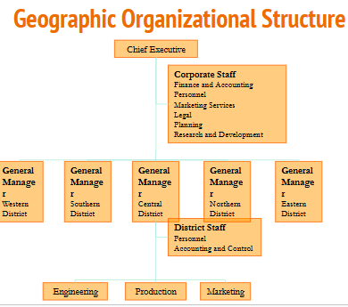

**Strategic Advantages/Disadvantages**

*Strategic Advantages*

* Allows tailoring of strategy to needs of each geographic market
* Improves coordination within the market
* Takes advantage of economies of local operations

*Strategic Disadvantages*

* Greater difficulty in maintaining consistent company image across areas
* Can result in duplication of staff services at headquarters and district levels, making a relative-cost disadvantage

**3) Product line structure**

A product line structure is a structure that is based around the different types of product that an organization produces.

For example, where a motor vehicle manufacturer organizes around types of vehicle.

* Companies that produce and market a substantial piece of software for corporate customers – a multi-user accounting package
* For example – often organize themselves into three main operational divisions: development and maintenance of the software, consultancy, and training. This should be regarded as a product line structure since the three types of activity, providing software, giving advice to companies in how to use it, and providing training for customer staff, can be considered to be different services that the company provides and they are typically provided by different teams of people.

**Advantages:**

1. **Specialization and Focus:** Each division is dedicated to a specific product or service, allowing teams to develop in-depth expertise and focus on improving that product line.
2. **Clear Accountability:** Each product line has its own set of responsibilities, which clarifies accountability and can enhance decision-making within each division.
3. **Flexibility in Response to Market Changes:** The structure enables quick adjustments to product lines based on changes in demand or technological advancements.

**Disadvantages:**

1. **Duplication of Resources:** Different product lines may require similar resources, leading to redundancies and potentially higher costs.
2. **Isolation of Divisions:** Divisions may become isolated from one another, which can lead to missed opportunities for collaboration and shared learning.
3. **Inefficiency in Cross-Product Processes:** If customers need multiple products or services, the structure may create inefficiencies in providing an integrated solution.

**4) Structure by market sector**

* Structure by market sector means structure based on the different market sectors to which its customers or prospective customers belong.
* From the sales and marketing point of view it has the great advantage that each division can fairly readily identify its potential customers, and its staff, both sales and technical, are likely to be familiar with customers’ problems and to speak a language that the customer understands.
* Example: Different branches of BATA.

**Advantages:**

1. **Customer Focus:** Each division can specialize in understanding and addressing the unique needs of its specific market sector, which can lead to better customer satisfaction.
2. **Effective Marketing and Sales:** Sales and marketing teams within each sector are likely to communicate effectively with customers and address their specific needs, enhancing the chances of successful sales.
3. **Enhanced Responsiveness:** The organization can more easily adapt to changing needs within each market sector, as divisions are in close contact with their respective customer bases.

**Disadvantages:**

1. **Knowledge Silos:** Divisions may not communicate well with each other, which can lead to redundancy or missed opportunities to share expertise across sectors.
2. **Risk of Market Saturation:** Focusing too closely on traditional sectors can lead to stagnation, as the company may overlook emerging markets or new opportunities.
3. **Resource Duplication:** Different sectors may have similar needs, leading to duplicated efforts and resources, increasing operational costs.

**5) Structure by technology**

* A technology-based structure was once a favorite model for software companies.
* A company might have divisions specializing in artificial intelligence, communications, web-based systems, databases, and real-time systems.4

**Advantages:**

1. **Expertise Development:** Teams can specialize in specific technologies, allowing them to deepen their expertise and keep up with technological advancements.
2. **Innovative Solutions:** With a technology focus, divisions are well-positioned to innovate within their specialties, potentially creating cutting-edge solutions.
3. **Efficient Use of Technology Resources:** Technology-specific divisions can be more effective in resource allocation, as they’re focused on their specific technological needs.

**Disadvantages:**

1. **Complex Customer Needs:** Many customers require solutions that use multiple technologies, making it difficult to meet their needs with a strictly technology-based structure.
2. **Limited Market Responsiveness:** This structure is often not customer-centered, which can hinder understanding of customer needs and limit responsiveness to market demands.
3. **Difficulty in Sales and Marketing:** Sales teams may struggle to align specific technologies with customer needs, leading to inefficiencies in targeting the right clients.

**6) Operational structure**

* The actual operations of a company may be organized on a *project* basis or on a *production* basis, although the line separating the two may be vague.
* Project-based activity is not restricted to operations. Most research and development is organized on a project basis and such administrative activities as introducing a new accounting system or transferring a company’s head office are also to be regarded as projects, in that they last for a fixed length of time, after which they should be complete.
* Projects last a comparatively long time but the team carrying out the work only stays together for the length of the project. Production activities are comparatively short, but the team carrying them out stays in existence indefinitely.

**Advantages:**

1. **Flexibility in Project-Based Work:** Project teams are assembled based on current needs, allowing the organization to adapt quickly to new projects or initiatives.
2. **Enhanced Collaboration for Projects:** Team members come together specifically for the project’s objectives, encouraging close collaboration and focus on achieving the project’s goals.
3. **Efficiency in Production Activities:** Production teams operate continuously, which can lead to increased efficiency, streamlined processes, and reduced turnover costs.

**Disadvantages:**

1. **Temporary Team Dynamics:** Project teams are often disbanded after the project ends, which can lead to loss of knowledge and cohesion if members do not stay in the organization.
2. **Resource Allocation Challenges:** Switching between projects may create competition for resources, leading to conflicts and inefficiencies if not properly managed.
3. **Difficulty in Managing Long-Term Goals:** The transient nature of projects can make it difficult for the organization to focus on long-term strategy and sustained growth, as priorities shift with each project.

**DEPTH OF STRUCTURE**

The depth of an organizational structure is the number of layers in the

* structure – or, more precisely, the maximum number of layers, since not all
* parts of the structure will have the same number of layers. Organizational
* structures are often described as flat or, in contrast, deep or tall, according
* to whether the depth is small or large. For a given number of people, the
* depth of the structure will obviously depend on the number of people reporting
* directly to each manager; this is sometimes known as the manager’s *span*
* *of control*.

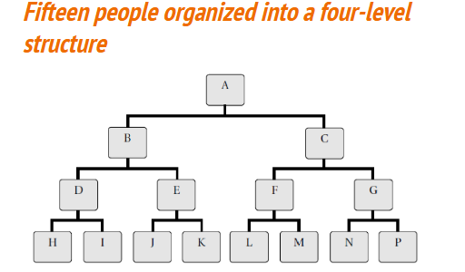

**CENTRALIZATION**

* Organizations may be centralized or decentralized. In a centralized company, as much power as possible is kept at the top of the company, with delegation only when essential. In a decentralized company, as much power and control as possible is delegated to the lowest level.

**SETTING UP A STRUCTURE IN PRACTICE**

In most cases, an organization of any size will have a structure that includes elements of several of the different types of structure.

A combination of different structures would help when adopted.

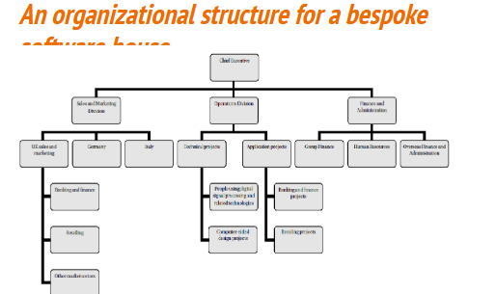

**Human Resource Management (HRM)**

* Human Resource Management (HRM) is the term used to describe formal systems devised for the management of people within an organization.
* Human resources is used to describe both the people who work for a company or organization and the department responsible for managing resources related to employees.

**Aim of HRM**

* The term ‘*human resources*’ emphasizes the fact that the people who work for an organization are an vital part of the organization’s resources and the most important one.
* For this reason, the organization will try to ensure that it always has appropriately skilled, qualified & experienced staff that it needs.
* This must be done without wasteful over-staffing and within the constraints of what is lawful.
* 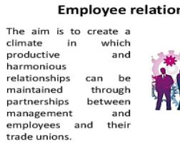

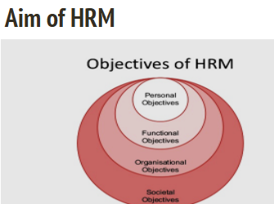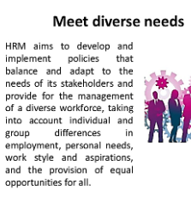

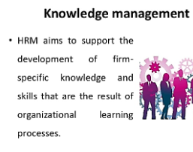 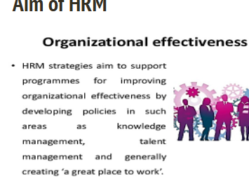 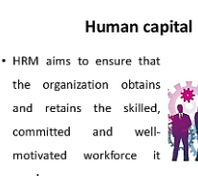

**Aim of HRM…**

* The cost of recruiting new staff is high and the loss of continuity when staff leave can also be very expensive.
* Accordingly the organization will want to keep staff turnover low.
* Many organizations want to behave as a ‘good’ employer and will therefore try to follow the best of current employment practice.
* Any organization that employs staff will be faced with the need to handle administrative issues relating to their employment.
* As the number of employees grow, a full-time personnel officer or human resources manager will be required.
* However, managers cannot hand over all responsibility for personnel matters to specialists.
* This is true specially in the IT industry, where staff have high expectations and staff turnover is particularly high.

**Recruitment and selection**

Human resources managers often make a distinction between the two terms *recruitment* and *selection.*

* Recruitment is the process of soliciting applications for jobs.  It is often handled partly or entirely by consultants.
* Selection is the process of selecting from the available applicants.

While recruitment consultants may screen the initial applications, they don’t usually do the final selection.

1. Recruitment Example: A company needs software developers. It posts job openings on LinkedIn and other job portals, encouraging applications from a wide range of candidates. The company's HR or a recruitment consultant handles the process of gathering applications.
2. Selection Example: Once 100 applications are received, HR shortlists 20 candidates for interviews. After interviewing, the company selects the best candidate based on skills, experience, and fit for the role.

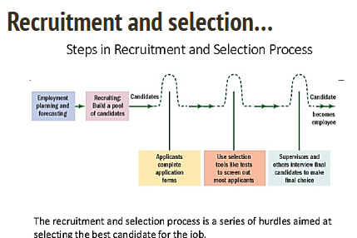

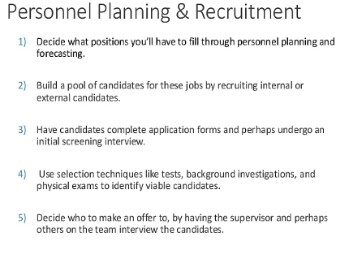

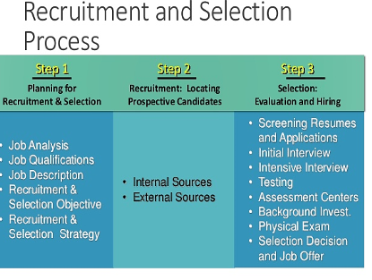

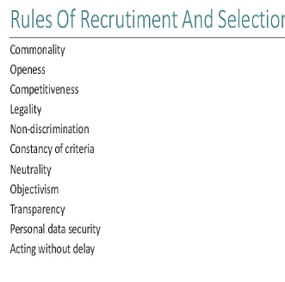

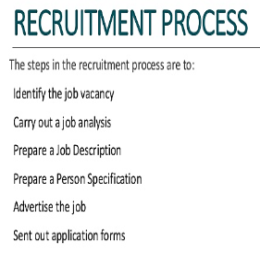

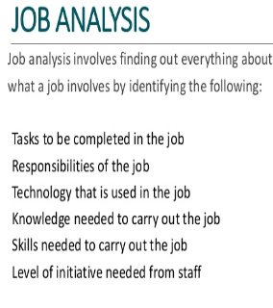

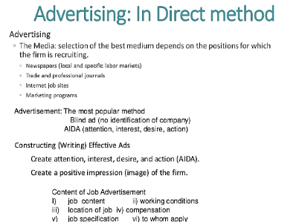

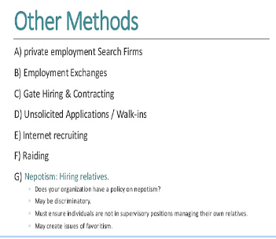

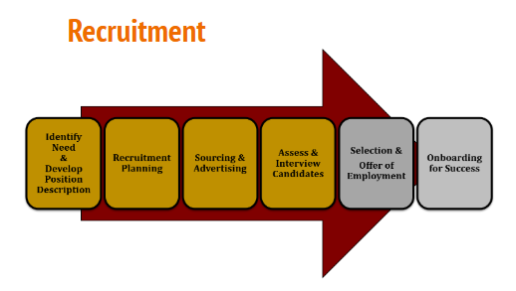

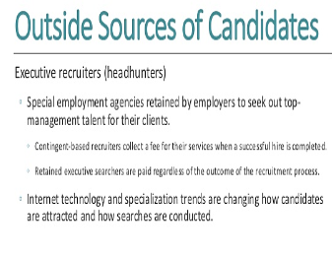

**Selection techniques**

Selection is made mostly by the employer, although a member of the recruitment agency staff may also be used to advise.

Following are some of the selection techniques used in making professional appointments:

* One-to-one interviews with several senior managers and technical staff
* Interview by a panel
* Assessment of references
* Aptitude tests
* Situational assessment
* Task assessment

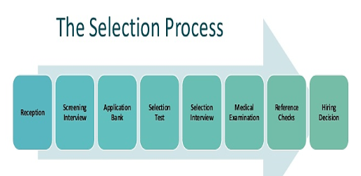

**Staff training and development**

* Staff training and development are of particular importance in high technology companies, where failure in this respect can threaten the company’s reputation.
* It is unfortunate that, when money is tight, it is often the first thing to be cut.
* Companies Identify training & development needs during appraisals/reviews. They give staff a guarantee of at least 10 days training a year.
* This training in specific skills is only useful if they can be exercised straightaway
* Development/education has long term impact
* Can be a good way of keeping staff

**TAKEOVERS AND OUTSOURCING :** Employees employed by the previous employer when the undertaking changes hands automatically become employees of the new employer on the same terms and conditions. It is as if their contracts of employment had originally been made with the new employer. Thus employees’ continuity of employment is preserved, as are their terms and conditions of employment under their contracts of employment (except for certain occupational pension rights). Representatives of employees affected have a right to be informed about the transfer. They must also be consulted about any measures which the old or new employer envisages taking concerning affected employees.

**Remuneration policies**

One of the major sources of staff dissatisfaction in organizations is perceived disparities in remuneration, (Remuneration means salaries + Benefits).

A good remuneration policy aims are:

* Staff retention (or controlled loss!)
* Consistency of treatment within the company, to avoid discontent
* Comparability with conditions outside the company.

**Appraisal schemes**

* It is astonishing that people working for years in a professional job without anyone, colleague or superior, giving them any indication of how well they are doing the job or how they might improve.
* This was commonly the case for school teachers, university lecturers, many civil servants, and managers in commercial and industrial organizations.
* It is still true of many doctors, solicitors, architects, etc.
* Till recently, there were no procedures or regulations that ensured that there was any such feedback.
* It is the job of the human resources management to design procedures to avoid this undesirable situation.
* Appraisal schemes are the usual formal way of doing this. They derive from the idea of Management by Objectives (MBO).
* A good appraisal process provides an effective way of fulfilling the requirements of a professional body and It must:
* Set agreed objectives
* Monitor and review performance against objectives
* Set new or modified objectives
* Assess training needs
* Discuss career ambitions

**Failure of appraisal schemes**

However great, appraisal schemes usually fail due to the following reasons:

* There’s always something more urgent than the appraisal interview.
* Seen as ineffective – good appraisal reports don’t lead to anything; no one takes any notice of what was agreed.
* Appraisers who don’t know anything about the appraiser's work.
* More emphasis on the measurable criteria.

**Redundancy and dismissal**

* *Redundancy* occurs when staff are fired because there is insufficient work for them. They may be eligible for compensation.
* *Dismissal* means firing staff because there work is unsatisfactory.
* In both cases it is important to have procedures and to follow them, in order to avoid litigation/legal action.
* The HRM department is responsible for setting up these procedures and advising the company on how to use them.

**Dismissal Procedures**

Following are the dismissal procedures:

* employer must give employee a written statement of why dismissal is being considered;
* employer must arrange a meeting at which both sides can state their case;
* employer must inform employee of decision, in writing;
* employee must have right to appeal to a more senior manager, where this is practicable.
* Any dismissal that does not follow or incorporate this procedure will automatically be considered unfair.
* Simply following the procedure does not, however, automatically make the dismissal fair.

**Contracts of Employment**

* According to Law, every employee must have a contract of employment.
* What this means is that the agreement between an employee and their employer can be enforced in a court of law.
* A good contract of employment should be written in terms that are easily understood and should avoid legal jargon.

Prospective employees should not need to consult a lawyer in order to understand it. They should, however, read it carefully before signing it.

**Human resource planning**

* If the human resources department wants to ensure that the organization always has the staff available it needs, it must be able to forecast the needs some time ahead.
* This is extremely difficult, particularly in software companies.
* From software houses through banking, manufacturing and retailing the uncertainty is always present, but it can be reduced to possibly predict staff needs much more precisely.

In a **software house**, there are three inputs to the human resource planning process:

* Human resource plans from existing projects, showing how many staff of each grade and with which specialized skills will be required in each of the following months.
* Sales forecasts: These are subject both to the unexpected behavior of potential clients and the judgement, good or otherwise, of the sales staff.
* Forecasts of the likely staff losses in the coming months: In the software business this depends very much on the buoyancy of the market for software developers.
* From these inputs, it can be predicted as to how many staff will be required each month, and how many will be available.
* In practice, human resource prediction in project-based companies never works very well and there are good statistical reasons why it never will.
* If we are summing 1,000 weighted predictions, the uncertainty in the sum will be quite small, even though the uncertainty in each prediction may be quite large; this is called the Law of Large Numbers.

**Job Design**

* Setting up an organizational structure implies designing jobs. As soon as a one-person organization becomes a two-person organization, it has to decide who does what; in other words it has to design jobs.
* In project-based organizations, jobs get designed when the project team is set up and when the project plan is produced.
* The jobs are temporary – they last only as long as the project – and the technical nature of the project determines exactly what tasks the jobs have to cover.

The **job design in IT companies** is done within an established framework:

* a project-based organization will have procedures in which project teams are to be structured

Such procedures may mandate the use of chief programmer teams in certain circumstances, or specify the maximum span of control and the responsibilities of team leaders, and project quality assurance (QA) staff in a hierarchically organized project.

* The tasks to be carried out will be defined by the development methodology that the company uses.
* **In many large organizations structured along bureaucratic lines, job specialization leads to very narrow and tightly defined jobs.**
* **As a result, the people carrying out those jobs find them dull and unsatisfying. This in turn leads to poor performance and high turnover.**

In an effort to alleviate this problem, companies have tried three different ways to provide more interesting and satisfying jobs: ***job rotation*, *job enlargement*, and *job enrichment*.**

**Scenario**

* ***Job rotation*** is rotating staff through series of jobs, is the most obvious way of preventing employees from becoming bored with a very narrow and specialized task.
* Consider handling of creditor’s invoices in a large accounts department with a very specialized regime.
* An analysis of the process might identify the following tasks, which then might be allocated to the individuals named: Freda, Gareth, John, Peter, Julie.

**Tasks**

1. Receive incoming invoice and match to purchase order (Freda)

2. Confirm price calculations and despatch to receiving Department for confirmation that goods or services have been received (Gareth)

3. Receive confirmation from department and pass for payment (John)

4. Produce payment (Peter)

5. Handle queries arising at any of the above stages (Julie)

**Job rotation**

Freda, Gareth, John and Peter move round every week.

* It gives staff a greater variety.
* It gives department greater resilience or elasticity in the case of sickness, holiday or resignation.

**Job enlargement**

*Job enlargement* means each of these members does tasks 1 to 4 for a particular group of invoices (e.g. particular suppliers or particular divisions).

* It adds variety and interest, and may increase pride in job.
* It may not be consistent with separation of responsibilities in financial matters.

**Job enrichment**

*Job enrichment* means adding more responsibilities, to say, Julie’s job.

* It is very effective for some staff members.
* Others may not want too much responsibility.

**WHAT IS DISCRIMINATION?**

* Discrimination means treating one person or one group of people less favorably than another on the grounds of personal characteristics.
* Discrimination can be *direct* or *indirect*.

**Discrimination Grounds**

In Europe, the USA and many other countries prohibits discrimination on grounds such as:

* sex, Gender;
* race, colour, ethnic origin or nationality;
* disability;
* sexual orientation;
* religion;
* age.

**Direct discrimination**

* Direct discrimination occurs when one person is treated less favourably than another specifically because of their sex or race, and so on.

Examples

* A woman does exactly the same job as a man but is paid less than he is.
* A doctor refuses to treat a Chinese patient on the grounds that he has no room for any more patients but then accepts an English patient.
* A company advertises for a secretary and automatically rejects all the male applicants.
* A company advertises for ‘a mature woman to act as the Chief
* Executive’s personal assistant’ or ‘a strong young man to work as a trainee zoo-keeper’.

**Indirect discrimination**

Indirect discrimination occurs when an employer imposes conditions that apply to all employees or all applicants but have a disproportionate effect on one group.

Examples

* Advertising a job with the requirement that applicants must be at least 180 cm tall. In the UK, there are many men over 180 cm tall but very few women. The result is that few women can apply for the job.
* When allocating public housing, a local authority has a policy of giving priority to the children of existing tenants.
* An employer insisting that all employees work on Saturdays. This might be held to be indirect discrimination against those who practice Judaism, since Saturday is their Sabbath. This would be discrimination on grounds of religion but, since the practitioners of Judaism are overwhelmingly of the Jewish race, it might also be regarded as racial discrimination.

It can be justified if the employer demonstrates that there is a genuine occupational requirement that the offending condition be satisfied.

**Direct discrimination  & indirect discrimination**

* **Direct Discrimination** occurs when someone is treated less favorably than others because of a protected characteristic such as race, gender, age, disability, etc. This form of discrimination is obvious and intentional.

**Example:** If an employer refuses to hire a woman simply because she is a woman, this is direct discrimination. For instance, during an interview, a company might say, "We don't hire women for this role," which is clear discrimination based on gende

* **Indirect Discrimination** happens when a policy, rule, or practice appears neutral but disadvantages a group of people who share a protected characteristic. It’s often unintended but still harmful.

**Example** A company introduces a policy that all employees must work late shifts. While this policy applies to everyone, it could disadvantage employees with childcare responsibilities, disproportionately affecting women, who are more likely to be primary caregivers. Even though the rule is the same for everyone, it indirectly discriminates against women.

**DISCRIMINATION ON GROUNDS OF Gender**

* Formally women got low salaries and men got extra allowances and more if they are married
* Married women were either to loose their job or transferred to temporary status
* Women after having kids were not allowed to rejoin
* it was very difficult for women to gain entry to academic and professional courses in fields such as medicine or the law that would have qualified them for senior positions.

**Key Anti-Discrimination** **Laws**

**1.** **Equal Pay Act (1970) and Sex Discrimination Act (1975) (UK)**: Unlawful to discriminate in employment, education, and service provision based on sex or marital status.

**2.** **Race Relations Act (1976):** Prohibits racial discrimination, including indirect discrimination, and established the Commission for Racial Equality.

**3.** **Disability Discrimination Act (1995):** Prohibits discrimination against disabled persons unless there’s substantial justification.

**4.** **Employment Equality Regulations (2003):** Protect against discrimination on the grounds of sexual orientation and religion, particularly in employment and education.

**5. AgeDiscrimination:** The Equal Treatment Directive allows certain age-based discrimination for protection, insurance rates, and eligibility for roles or benefits.

**Act of Parliament**

In UK this situation was dramatically changed by two Acts of Parliament:

* the **Equal Pay Act of 1970** and
* the **gender Discrimination Act of 1975**.

The most important features of the law as it stands can be summarized as follows:

* **Regarding Employment**
* **Regarding Education**
* **Regarding Provision of services**

**Act of Parliament Regarding Employment**

* It is unlawful for employers to discriminate based on **gender** or **marital status** in several aspects of employment. Specifically:
* **Recruitment and Selection:** Employers cannot discriminate when recruiting or selecting employees. This includes job offers and the terms of employment.
* **Promotion, Transfer, or Training:** Employers must provide equal opportunities for promotion, transfer, and training, without discriminating against employees based on sex or marital status.
* **Dismissal or Redundancy:** It is illegal to dismiss an employee or make them redundant because of their gender or marital status.
* **Victimization:** Employees who bring complaints about gender discrimination, or who support another employee's complaint, are protected from victimization. Employers cannot retaliate against them.

**Act of Parliament Regarding Education**

* It is unlawful for a provider of education (public or private, school, college or university) to discriminate against a person on the basis of their gender, in offering admission to the establishment or to specific courses, and in providing access to the other benefits and facilities it offers.

**Act of Parliament Regarding Provision of services**

* It is unlawful to discriminate on grounds of gender in the provision of goods, facilities or services. The Act gives a number of examples including accommodation in a hotel, facilities for entertainment, recreation or refreshment, banking and insurance services, and so on.
* It is unlawful to discriminate on grounds of ge in selling or letting property.

The main exception to these provisions are for charities that have been founded with the purpose of helping a specific group of people who are all of the same sex, for example, single mothers.

**Case:**

* In 2017, it was revealed that male presenters at the BBC were earning significantly more than their female counterparts for doing the same work. BBC's China editor, Carrie Gracie, resigned from her position, accusing the organization of paying her less than male colleagues in similar roles. The BBC later apologized and agreed to pay backdated wages to address the issue.
* **Based on this scenario, what type of discrimination was experienced by Carrie Gracie at the BBC, and which UK law does it violate?**

**Case:**

* Carrie Gracie, the BBC’s China editor, discovered that she was being paid significantly less than her male counterparts in similar roles. Despite her equal qualifications and job responsibilities, the BBC failed to offer her the same salary. She resigned and filed a complaint, resulting in backdated wage payments and an apology from the organization.
* **What type of gender discrimination does this case represent, and which UK law is specifically designed to protect against such unequal treatment in employment**

* **Answer 1:** This is an example of **direct discrimination** based on gender. Carrie Gracie and other female presenters were paid less than male colleagues for doing the same work. This violates the **Equal Pay Act of 1970**, which ensures that men and women must receive equal pay for equal work.
* **Answer 2:** The case represents **direct gender discrimination** in terms of unequal pay. This violates the **Equal Pay Act of 1970**, which mandates equal compensation for men and women doing the same or similar work. The law is designed to protect employees from gender-based pay disparities in the workplace.

**Remedies**

if an individual believes they have been discriminated against (e.g., unequal pay), they can take their case to an **employment tribunal**, a legal body that deals with work-related disputes.

* The tribunal will review the evidence and decide whether the complaint is valid.
* **If the tribunal finds in favor of the complainant (the person making the complaint)**, it can:
  + **Award damages**: Compensation for financial loss, emotional distress, or harm caused by the discrimination.
  + **Make recommendations**: The tribunal can instruct the respondent (the employer or organization) to take corrective actions, such as fixing the pay gap, changing discriminatory policies, or providing training to staff.
* **If the respondent fails to act on the recommendations**, the tribunal may **increase the amount of damages** awarded to the complainant, as a penalty for not complying with the tribunal's decision.

**Case: One notable real-time case where an employment tribunal made recommendations and awarded damages was the Allan vs. G4S Case (2016) in the UK, related to disability discrimination.**

**Case: Allan vs. G4S (2016)**

* Mr. Allan, who worked for G4S Cash Solutions, developed a disability and was transferred to a new role. He continued to work in the new role for several months, but then G4S decided to reduce his salary by 10% because they felt the new role was less demanding.
* Mr. Allan took the matter to an employment tribunal, claiming **disability discrimination**. He argued that the pay reduction was discriminatory, given that he was placed in the new role due to his disability.
* **Tribunal’s Decision:**
* The tribunal ruled in favor of Mr. Allan, finding that reducing his salary was an act of **disability discrimination**.
* The tribunal awarded Mr. Allan damages for the pay reduction and recommended that G4S should not reduce his pay in the future.
* **Outcome:**
* G4S was ordered to pay compensation, and the tribunal’s recommendations were aimed at ensuring that Mr. Allan would continue to receive the same salary as he had in his previous role.

**DISCRIMINATION ON RACIAL GROUNDS**

* The present law is based on the **Race Relations Act 1976** and subsequent amendments to it.
* It makes it unlawful to discriminate on grounds of race, colour, ethnic origin or nationality.
* It introduced the idea of indirect discrimination based on race. And it established the Commission for Racial Equality by the merger of the Race Relations Board and the Community Relations Commission.

**DISCRIMINATION ON GROUNDS OF RELIGION OR BELIEF, OR SEXUAL ORIENTATION**: As regards discrimination on grounds of sexual orientation and religious belief, the EU directive is implemented in the UK by the Employment Equality (Sexual Orientation) Regulations 2003 and the Employment Equality (Religion or Belief) Regulations 2003, both of which came into effect in December 2003. These regulations follow the pattern established by the Sexual Discrimination Act 1975 and the Race Relations Act 1976.

**DISCRIMINATION ON GROUNDS OF DISABILITY**

* **Disability Discrimination Act 1995**: Made it unlawful to treat disabled employees or service users less favorably without serious justification.
* Example: Rejecting a blind applicant for a bus driver position is justified, but employers must make reasonable adjustments (e.g., modifying equipment for disabled employees).
* **Reasonable Adjustments**: Employers are required to adapt the workplace for disabled employees.
* Example: Providing screen-reading software for visually impaired workers or modifying workstations for employees with limited mobility

**Disability Discrimination Act**

* **Access to Goods and Services**: Businesses must ensure that disabled people can access services, including on the web.
  + Example: Websites should be designed with features like screen reader compatibility, clear navigation, and proper text alternatives for images.
    - All images on the BBC website are labeled with alternative text descriptions, allowing screen readers to describe the images to users.
* Published **Web Content Accessibility Guidelines (WCAG)** to assist web developers in making web content accessible to disabled users.
  + Example: Ensuring clear page layouts, proper labeling of links/images, and avoiding poor contrast between text and background.

**Survey**

The **Disability Rights Commission** commissioned a study of web accessibility for the disabled, which resulted in a report entitled The Web: Access and Inclusion for Disabled People. The study included a survey of 1,000 home pages and found that 81 per cent, including many government sites, failed to comply with even the lowest level of the W3C guidelines. Among the commonest reasons why disabled users experienced difficulty were:

* page layout was unclear and confusing;
* the navigation mechanisms were confusing and disorienting;
* there was poor contrast between the text and the background and colours were used inappropriately;
* graphics and text were too small;
* links and images were poorly labelled;
* the web pages were incompatible with the software designed to assist disabled users (screen readers, magnification software).

**DISCRIMINATION ON GROUNDS OF AGE**

1. **Special treatment of different age groups to protect them**
   * This provision allows for age-related rules that protect certain age groups, particularly vulnerable ones like children.

* **Example:** A company may be prohibited from employing children under the age of 16. This rule is in place to protect minors from hazardous working environments and ensure that their education is not disrupted.

1. **Different premiums for life insurance and pension rates based on age**
   * This provision allows insurance companies to adjust premiums and pension rates depending on the person's age, as age is a factor that affects risk and life expectancy

* **Example:** A 25-year-old taking out a life insurance policy may pay a lower premium than a 55-year-old because younger people generally have a lower risk of death. Similarly, a person who retires at 60 might receive a lower monthly pension compared to someone who retires at 65, as they are likely to receive the pension for a longer period.

1. **Fixing a maximum age for recruitment based on the need for a reasonable period of employment**
   * In some cases, employers may set a maximum age for hiring new employees to ensure that there is enough time for the individual to be trained and contribute effectively before retiring.

* **Example:** A company offering a highly specialized job may set a maximum recruitment age of 45, because the role requires several years of training and the company expects employees to work for at least 15-20 years before retirement.

1. **Fixing a minimum age, experience, or years of service for certain posts or benefits**

Employers may require that employees meet specific age or experience criteria to be eligible for certain positions or employment benefits.

* **Example:** A company may require employees to be at least 30 years old or to have 5 years of professional experience before being eligible for a managerial role. Similarly, a company may offer additional annual leave only to employees who have worked for them for 10 years or more.

**AVOIDING DISCRIMINATION**

Effective compliance with anti-discrimination legislation in the workplace requires three things:

* a suitable written policy, well publicized, and freely and easily available;
* a training program for new and existing staff, to ensure that they are all aware of the policy and its importance;
* effective procedures for implementing the policy.

**WCGA Guidelines for developers:**

• **Perceivable:** Make content available to all senses. Provide text alternatives for images, captions for videos, and adaptable content for screen readers.

• **Operable:** Ensure all features are usable via keyboard and give users time to interact. Enable easy navigation for users with limited motor skills.

• **Understandable:** Use clear language and consistent layouts. Provide clear labels and instructions to make content intuitive for all users.

• **Robust:** Build content that works across devices and with assistive technologies. Use standards that ensure compatibility and adaptability over time.